**Ideation Phase**

**Define the Problem Statements**

|  |  |
| --- | --- |
| Date | 27 July 2025 |
| Team ID | LTVIP2025TMID30362 |
| Project Name | Citizen AI – Intelligent Citizen Engagement Platform |
| Maximum Marks | 2 Marks |

**Customer Problem Statement Template:**

**Citizens of urban and rural communities** who rely on municipal services like waste collection, water supply, road maintenance, grievance redressal, and local governance updates.

Citizens often face **inefficiencies, delays, or lack of transparency** when interacting with municipal bodies. **Feedback channels are limited, unresponsive, or hard to access**, making it difficult for people to report issues, track progress, or feel heard in decision-making processes.

This occurs **across various service touchpoints** — online portals, call centers, or physical offices — particularly when:

* Submitting grievances or suggestions
* Seeking updates on service requests
* Attending local civic meetings or accessing civic data

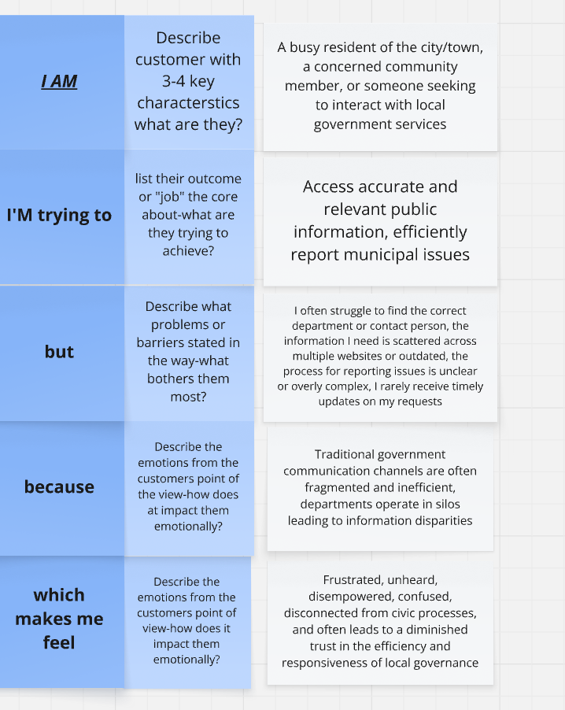

|  |  |  |  |  |  |
| --- | --- | --- | --- | --- | --- |
| **Problem Statement (PS)** | **I am (Customer)** | **I’m trying to** | **But** | **Because** | **Which makes me feel** |
| PS-1 | A citizen who expects modern, digital convenience | Get immediate, personalized answers to my specific questions about city services or local regulations at any time. | have to search through complex government websites, wait for office hours to call, or navigate automated phone trees that don't understand my query. | Current government digital platforms lack an intelligent, conversational interface and the ability to provide instant, tailored information. | Frustrated, impatient, and like my time is being wasted on simple inquiries |
| PS-2 | .A resident wanting to actively participate in local decision-making and civic life | Provide valuable feedback on proposed city projects or policies and feel that my input is genuinely considered | The official public consultation processes are often hard to find, require attending inconvenient physical meetings, or my written submissions feel lost among many others without clear acknowledgment | The official public consultation processes are often hard to find, require attending inconvenient physical meetings, or my written submissions feel lost among many others without clear acknowledgment | Disengaged, unheard, and as if my opinion doesn't truly contribute to civic outcomes |